Basic Git Commands (For managing repositories)
- git init: Initializes a new Git repository in the current directory.
Earlier git was initialized and now it was reinitialized in working directory
By initializing a .git folder will be created in the working directory
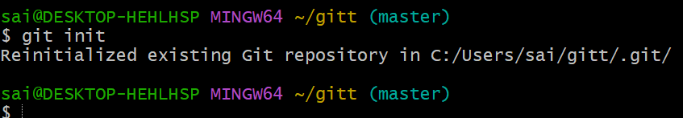

- git clone : Clones a repository from a remote URL to your local machine
git clone ssh/https url to clone the data or files from remote repository to local machine.
Using clone is not necessary for all times either use pull because clone will download all the data each time and git pull download only updates or modifications.

- git status: Shows the working directory status (which files are modified, staged, etc.)
git status will display us which files are not tracked or un staged and which are staged or tracked .
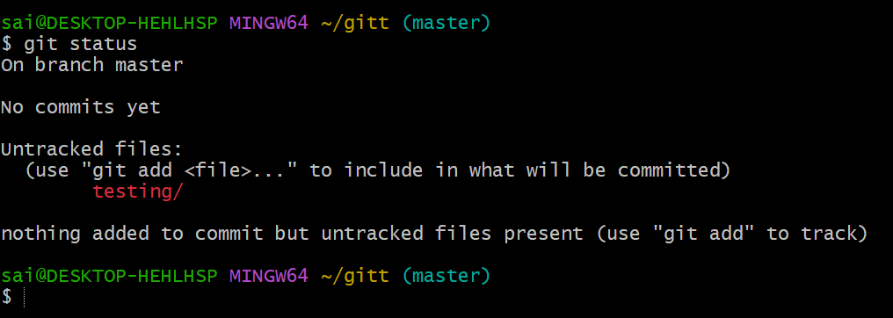

• git add : Stages a file or files to be committed.
If we need add the files to tracked or staged area from unstaged area we use git add command and file name ,else for adding multiple at once we use git add . command .
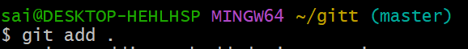
And you can see the status of the file
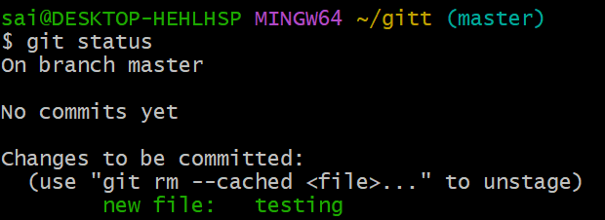

- git commit -m "message": Commits staged changes to the local repository with a message
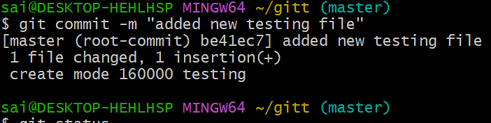
Else you can do in notepad++ by inserting message directly
You will be redirected to notepad++ and insert the message
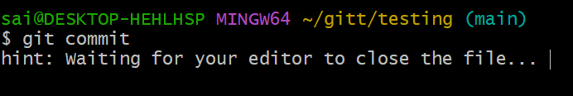
Just add message and save
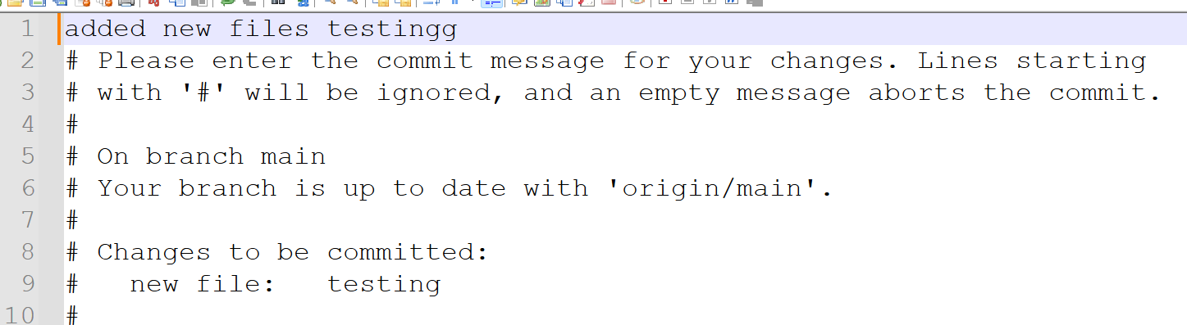
Here is the last output of commit command after editing in notepad++
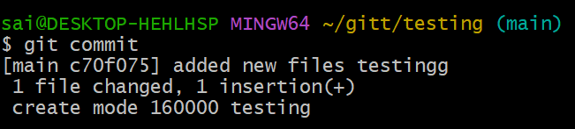

- git push: Pushes committed changes to the remote repository.
Changed the branch and created a push to remote repository
It only works if your local data is matching with your remote data
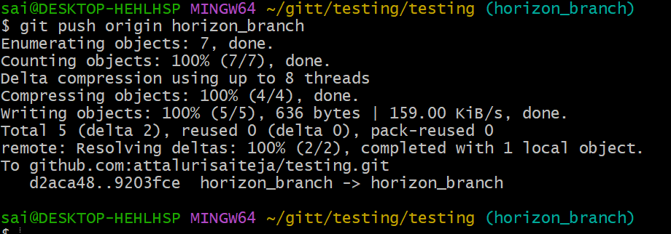
- git pull: Fetches and merges changes from the remote repository to your local working directory.
Git pull will help us to download updates from remote to local machine (only modifications & updates not all the files)
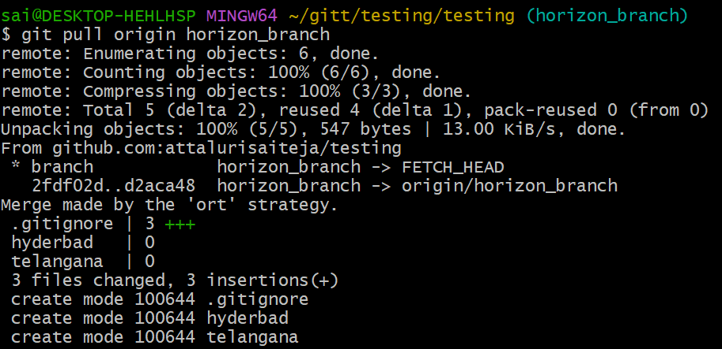

- git fetch: Downloads objects and refs from another repository (without merging)
git fetch just downloaded data from the remote it did not change your working tree or move your current branch
for a particular branch then you can use git fetch origin branch_name
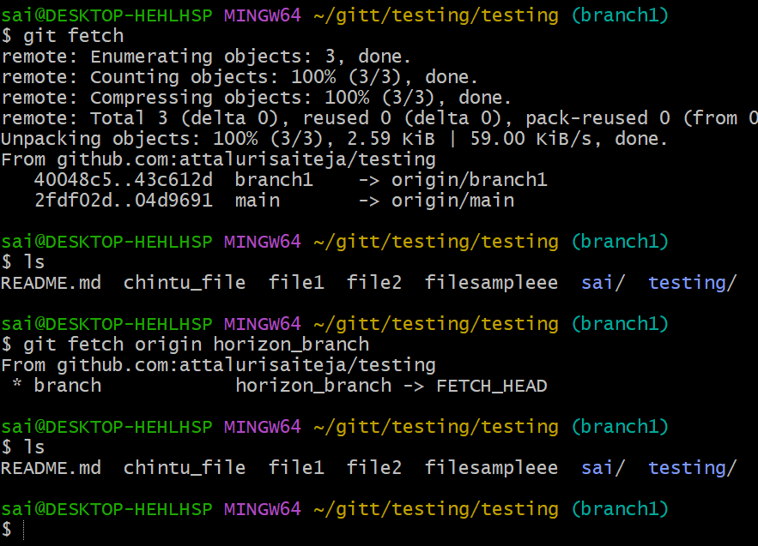

- git merge : Merges changes from the specified branch into the current branch
used git merge command to merge the branches and check the logs and confirmed commit id’s
git merge integrates changes from another branch (or commit) into your current branch.
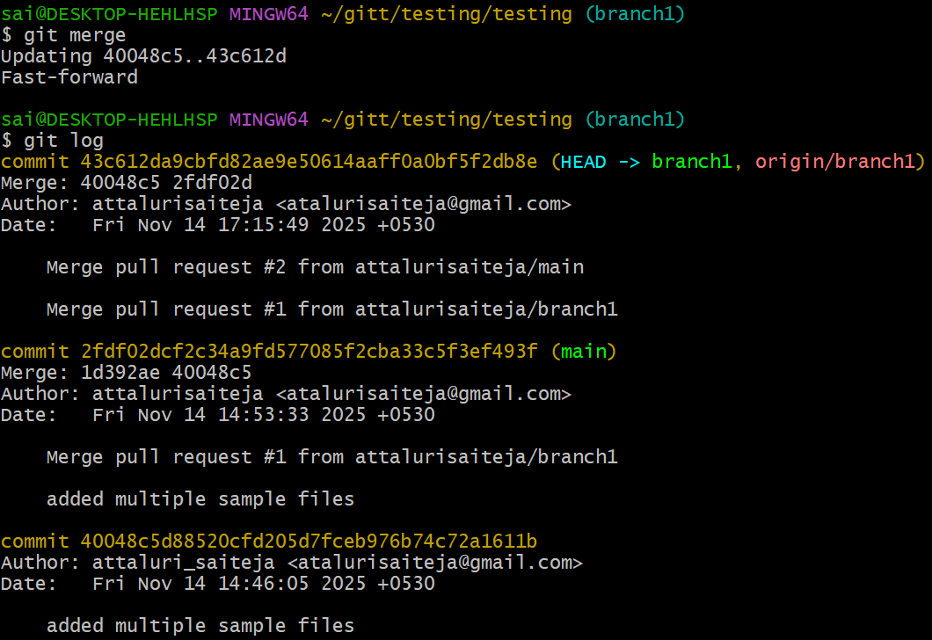
- git log: Shows the commit history of the repository
it displays previous commits and info about commit
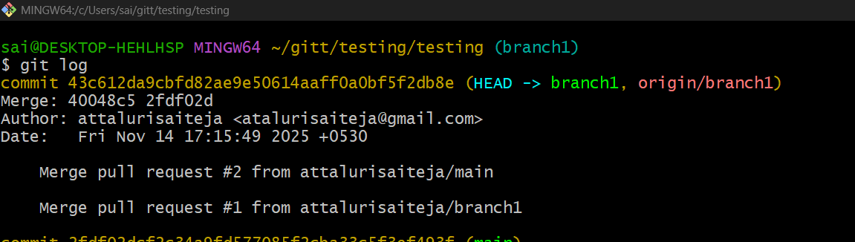
- git diff: Shows the differences between your working directory and the index (staged changes)
Compare current branch vs remote branch
git diff shows differences between:
- your working directory vs staged changes,
- your staged changes vs the last commit,
- or any two commits/branches you choose
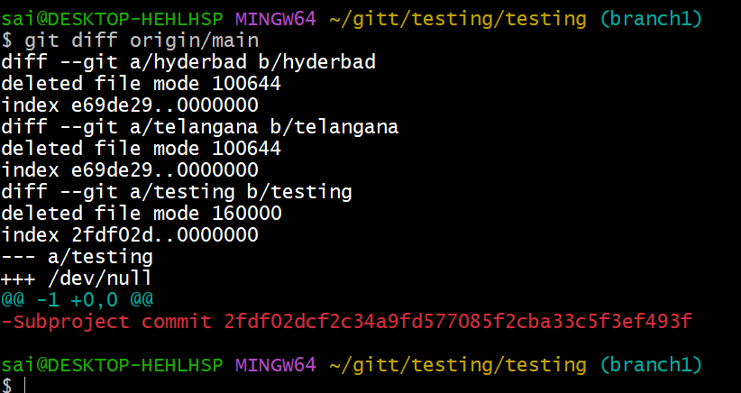
Difference b/w old and new modified files
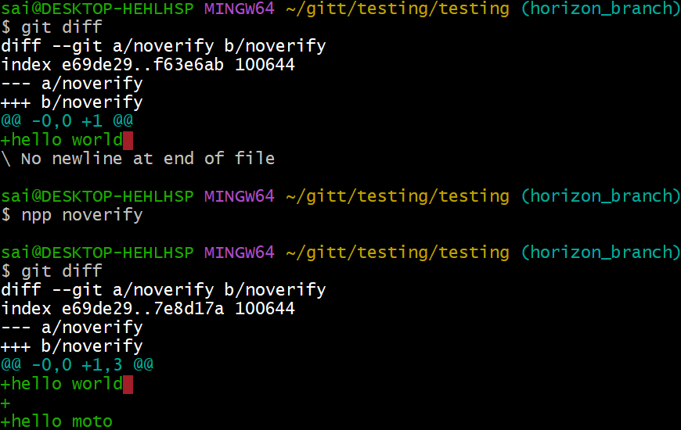

2. Branching Commands (Managing branches)
• git branch: Lists all branches in your repository.
* indicates present working branch or in which you are working
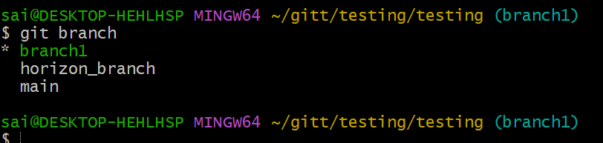
- git branch : Creates a new branch
we can create multiple branches in git not set to a particular number
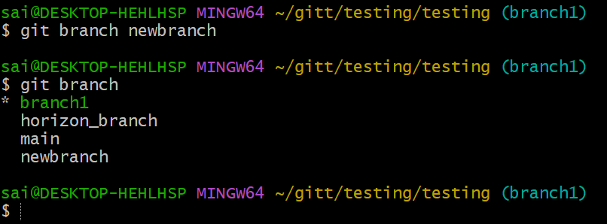
- git checkout : Switches to an existing branch.
Here branch has switched to branch to newbranch
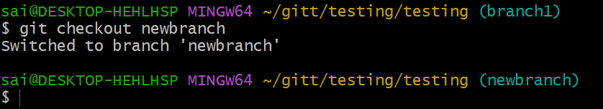

git checkout -b : Creates and switches to a new branch in one step.
Here by using this command we can create a new branch at once and switched to same which we created at same time.
Earlier we used two commands to do the same process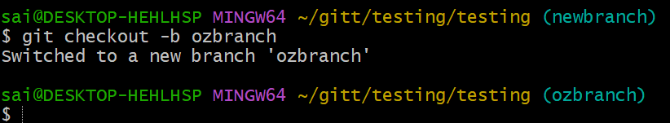
git merge : Merges changes from the specified branch into the current branch.
Data has merged from horizon_branch to ozbranch
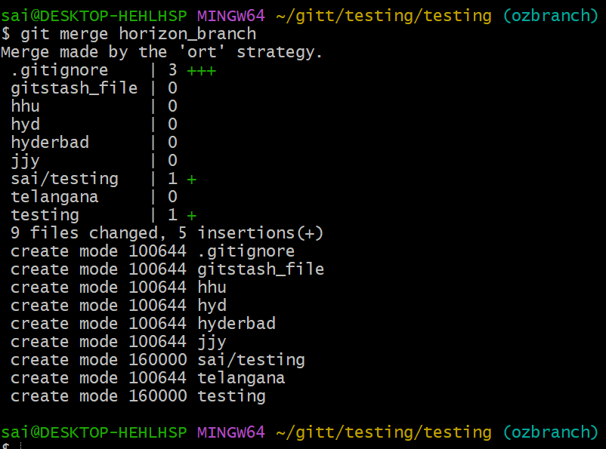

git rebase : Applies changes from one branch onto another branch (instead of merging).
git rebase is used to rewrite history by moving or replaying commits onto another base.
It is one of Git’s most powerful and most misunderstood commands.
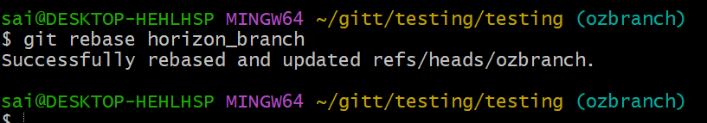
- git branch -d : Deletes the specified branch (locally).
git branch -D force deletes a local branch, even if it has unmerged commits.
Deleted a branch using git branch -D
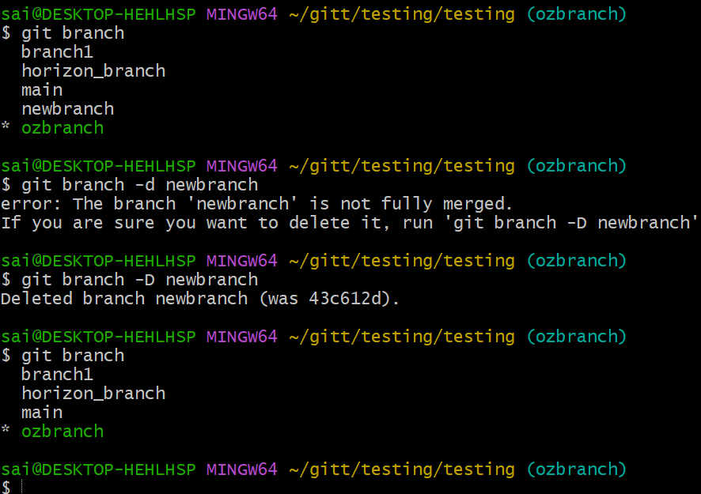

- git remote set-head origin : Sets the default branch for the remote repository
sets which branch Git considers the default branch for that remote (usually origin)
validated using git remote show origin command to display
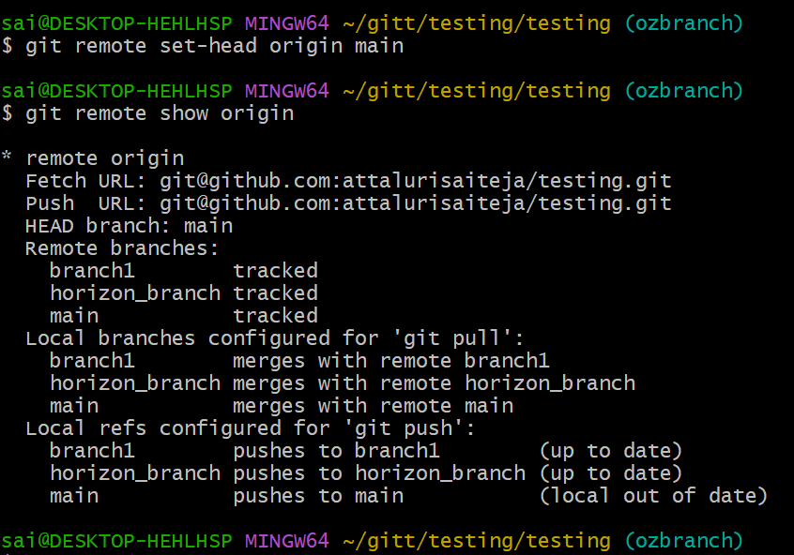

3. Remote Commands (Managing remotes and syncing with the cloud)
git remote -v: Shows the remote repository URLs.
Displays the repo link to remote server
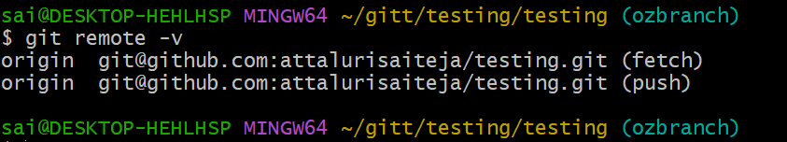
- git remote add : Adds a new remote repository.
If it is not added earlier then it will gets add or it will give an error output as you can see in the output
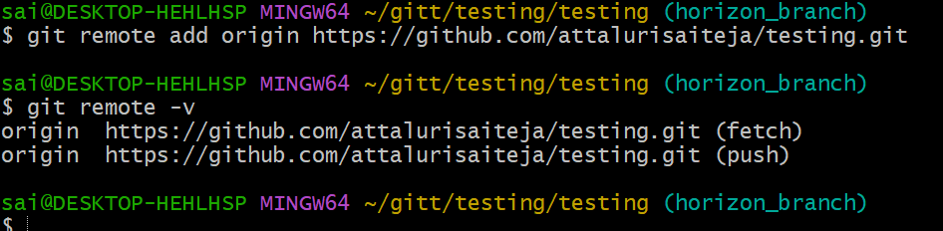
- git remote remove : Removes a remote repository
else you can use git remote rm origin command to do the same
remote server link has been removed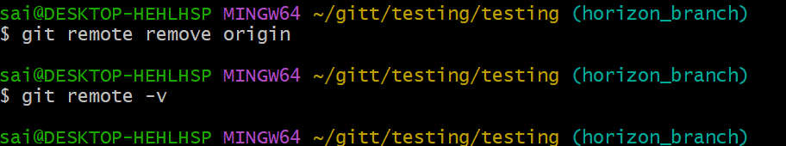

- git push origin : Pushes a branch to a remote repository.
It will pushes the local machine data or information to remote server
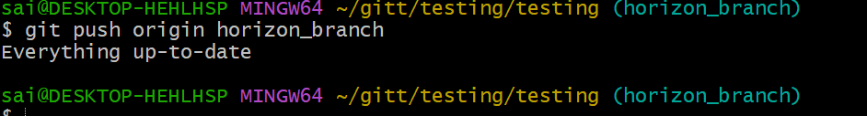
- git push -u origin : Pushes a branch to a remote repository and sets the upstream for the branch
u- upstream means main
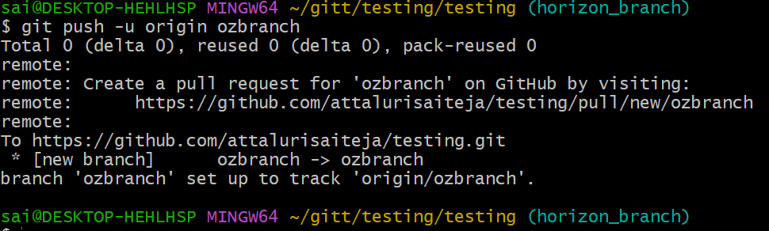
- git pull origin : Fetches and merges a branch from the remote repository.
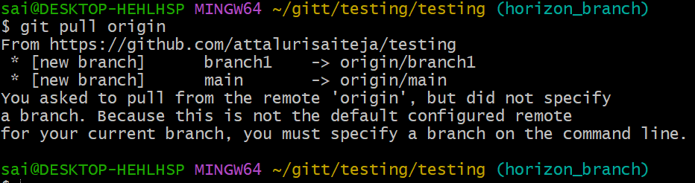

- git fetch origin: Downloads objects and refs from the remote repository.
Downloads objects and objects with out disturbing working directory happens in background
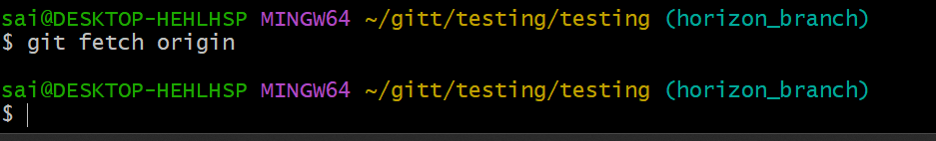
- git remote show origin: Displays detailed information about a remote repository.
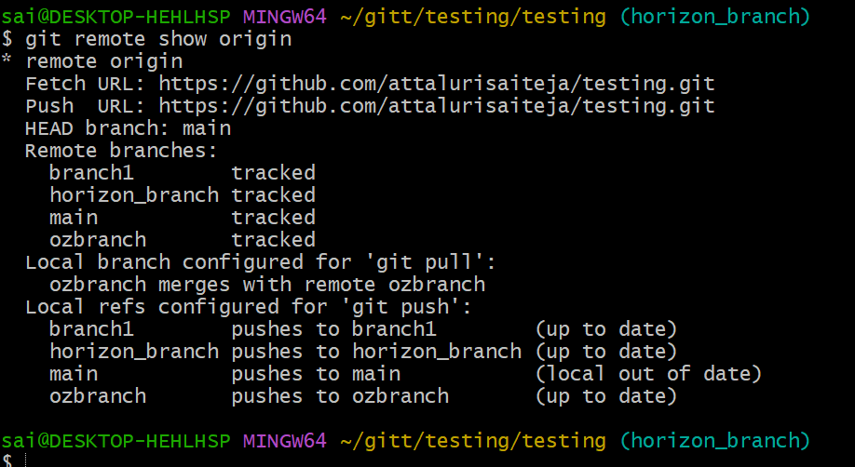

Staging and Committing (Managing changes)
- git add . : Stages all modified files in the working directory
git add . will add all the files in working directory to tracked area
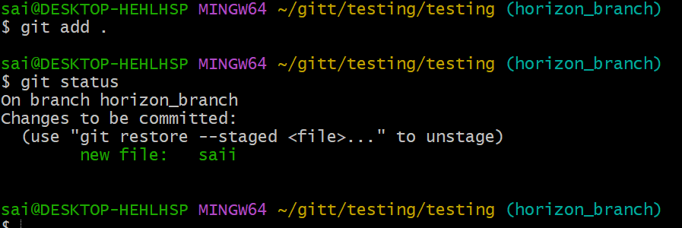
- git add -A: Stages all modified files (including file deletions)
git restore –staged filename for single file from tracked to untracked area
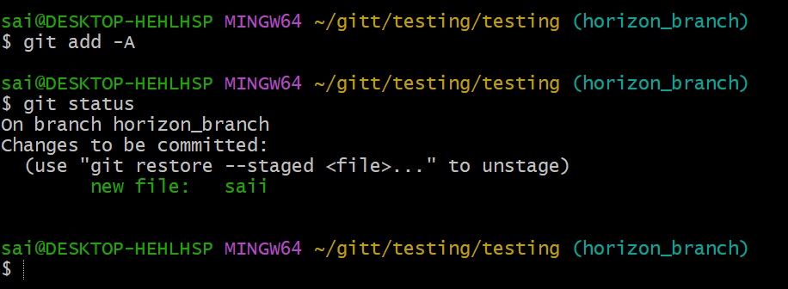

• git reset : Unstages a file (reverts it to the working directory).
It reset previous tracked files to untrack files
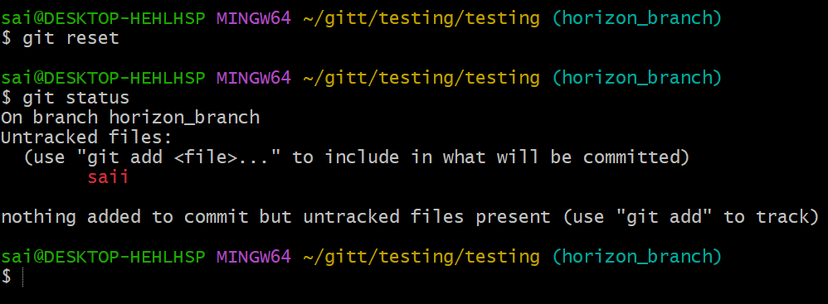
- git commit --amend: Modifies the last commit (can change the commit message or add changes)
you will redirected to editor and change the commit message add files or modify data using amend command
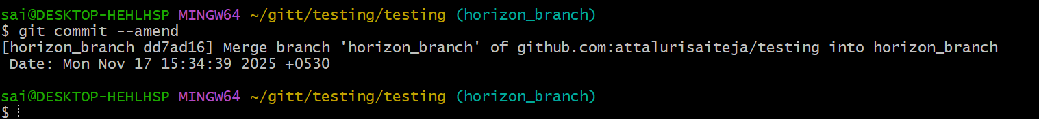
- git commit --all: Automatically stages tracked files and commits them
here you can give the message directly in editor
Automatically stages all modified and deleted tracked files
then commits them
Still does NOT include untracked files (new files)

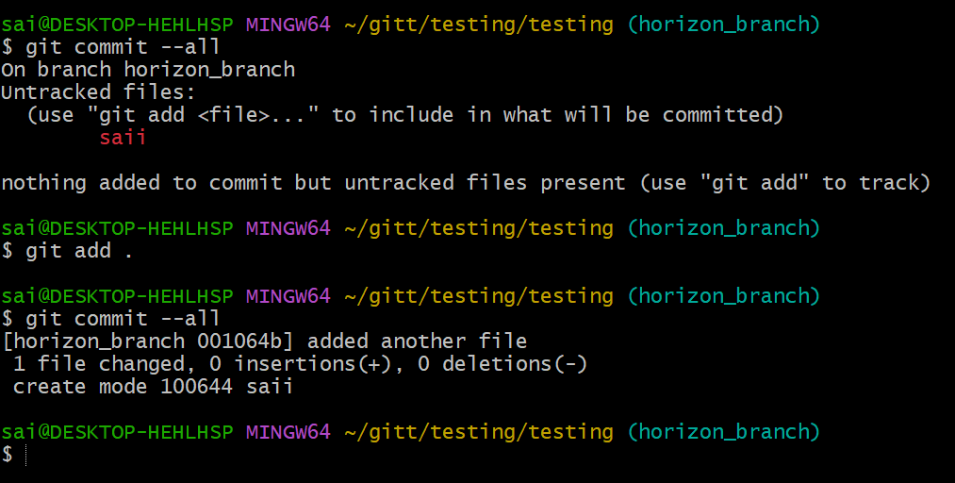
- git commit -a: Stages and commits all modified files.
This is used for automatically staging modified & deleted tracked files.
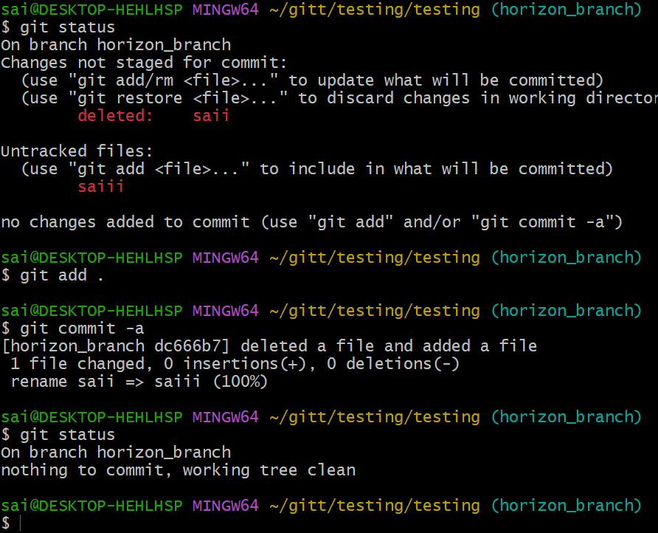
- git commit --no-verify: Skips pre-commit hooks while committing
Git will commit instantly even if your project has failing tests, lint errors, or invalid commit format in the hooks
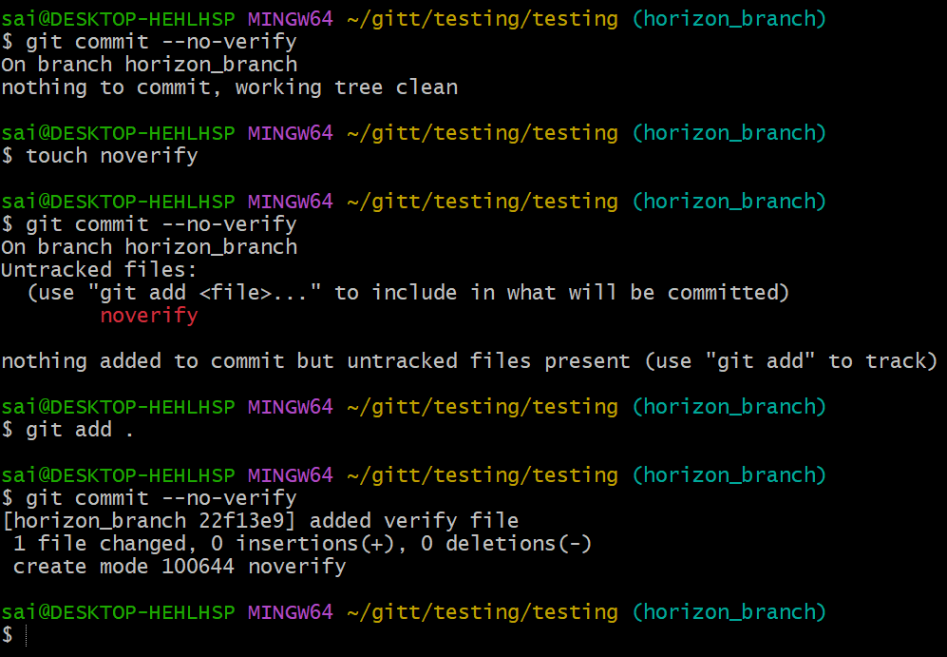
- git log –oneline command shows a single line about logs
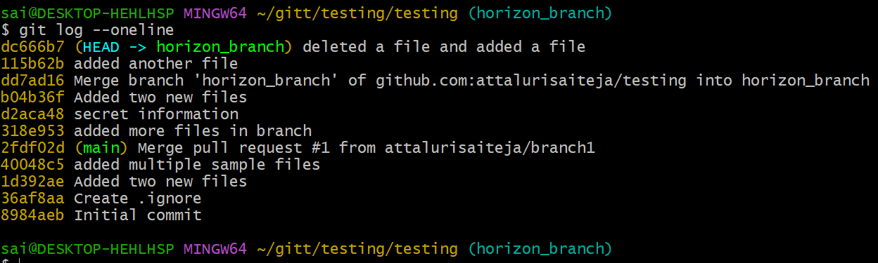

- git log – oneline –graph displays graphical representation
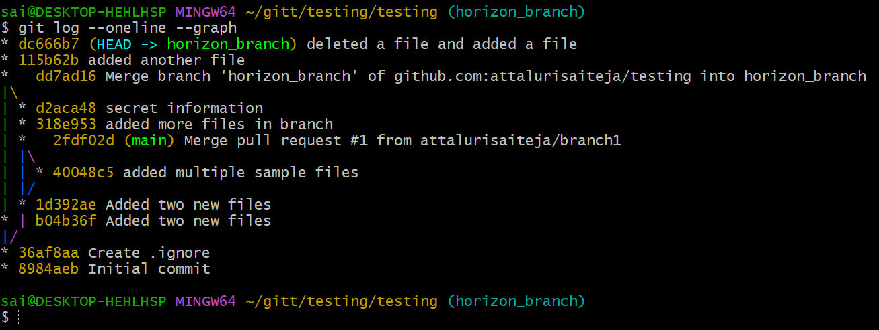
- git log – oneline –graph –all displays large graphical representation
- you can use git log –oneline –graph –decorate --all
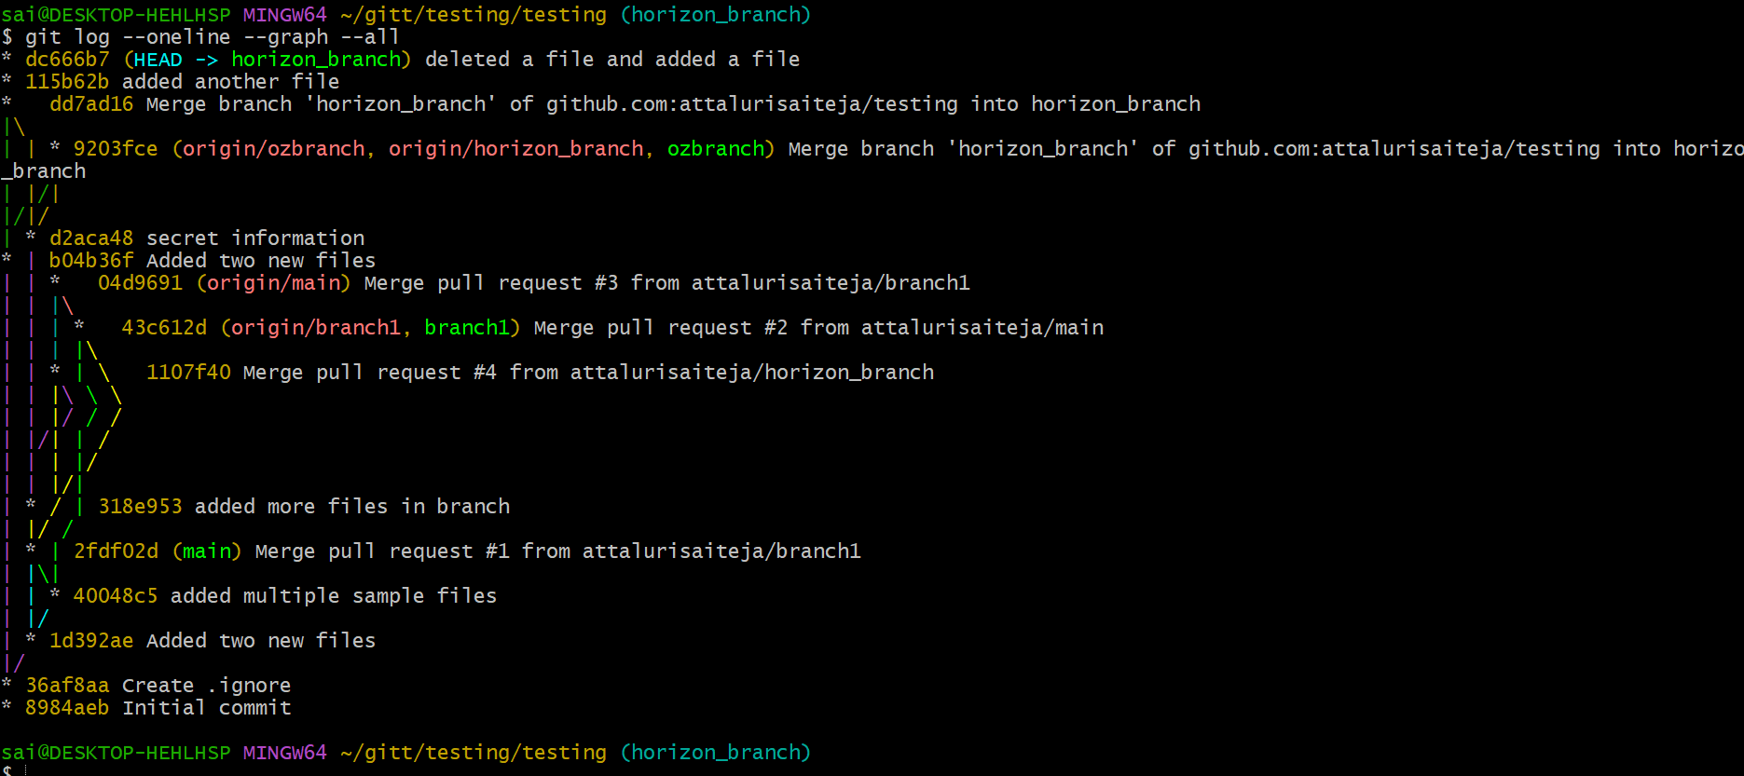

- git log -p will display utmost info on commits
The Patch (-p): This is the key part. It shows the diff—the line-by-line changes introduced by the commit.
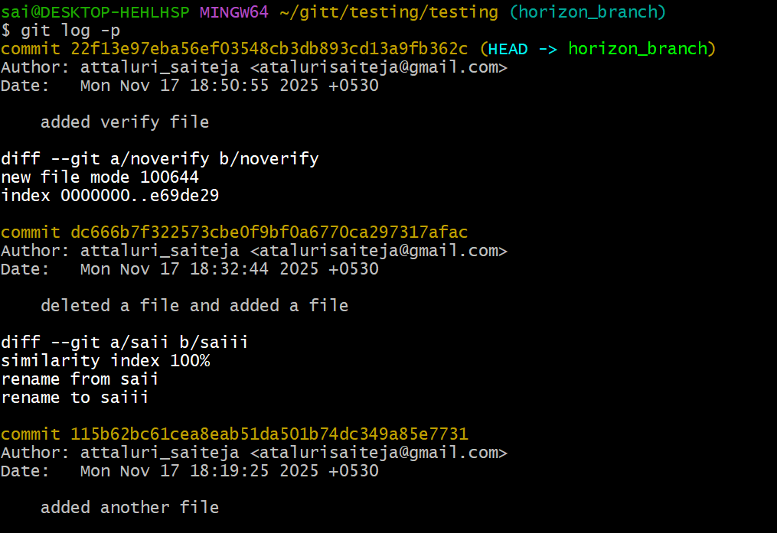

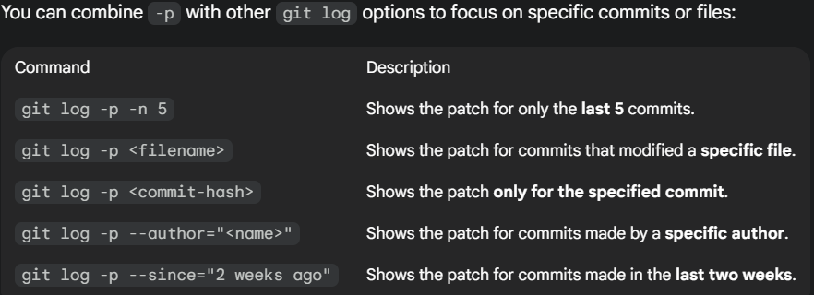

- git reset --soft HEAD~1: Moves the HEAD pointer back one commit but leaves your changes staged
Undo the last commit, but KEEP all the changes staged.
git reset --soft HEAD~1 undoes the last commit WITHOUT removing any of your changes.
Everything stays in the staging area, ready to recommit.
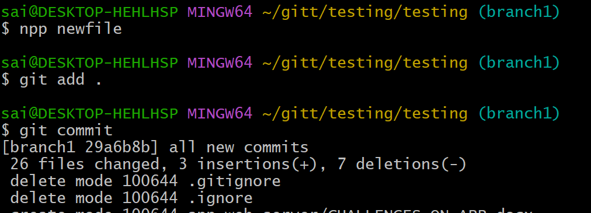
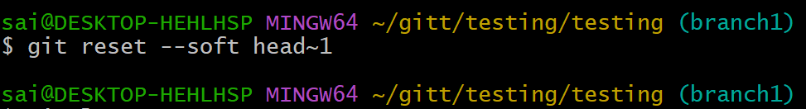
Again files could be seen in staged area
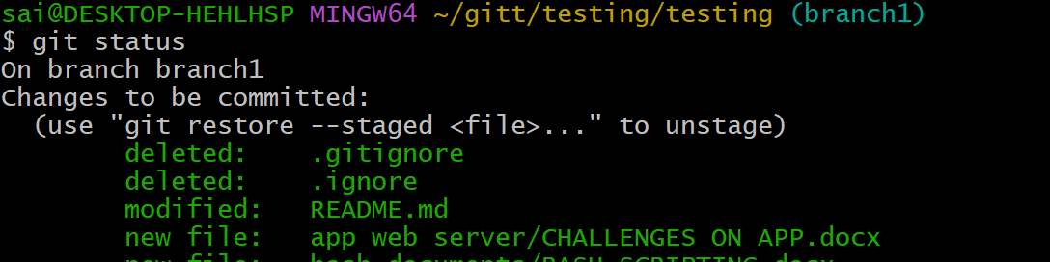

- git reset --hard HEAD~1: Moves the HEAD pointer back one commit and discards changes in the working directory.
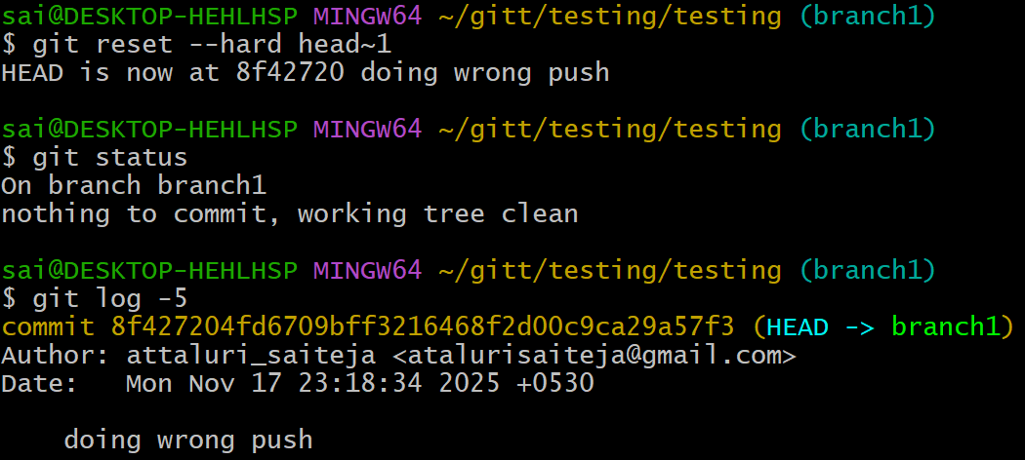

Viewing and Comparing Changes (Inspecting changes)
- git diff: Shows changes between your working directory and the index (unstaged changes).
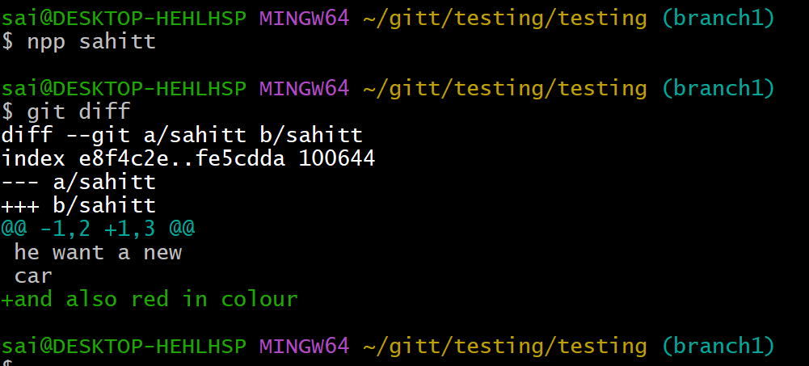

- git diff --staged: Shows changes between the index (staged files) and the last commit.
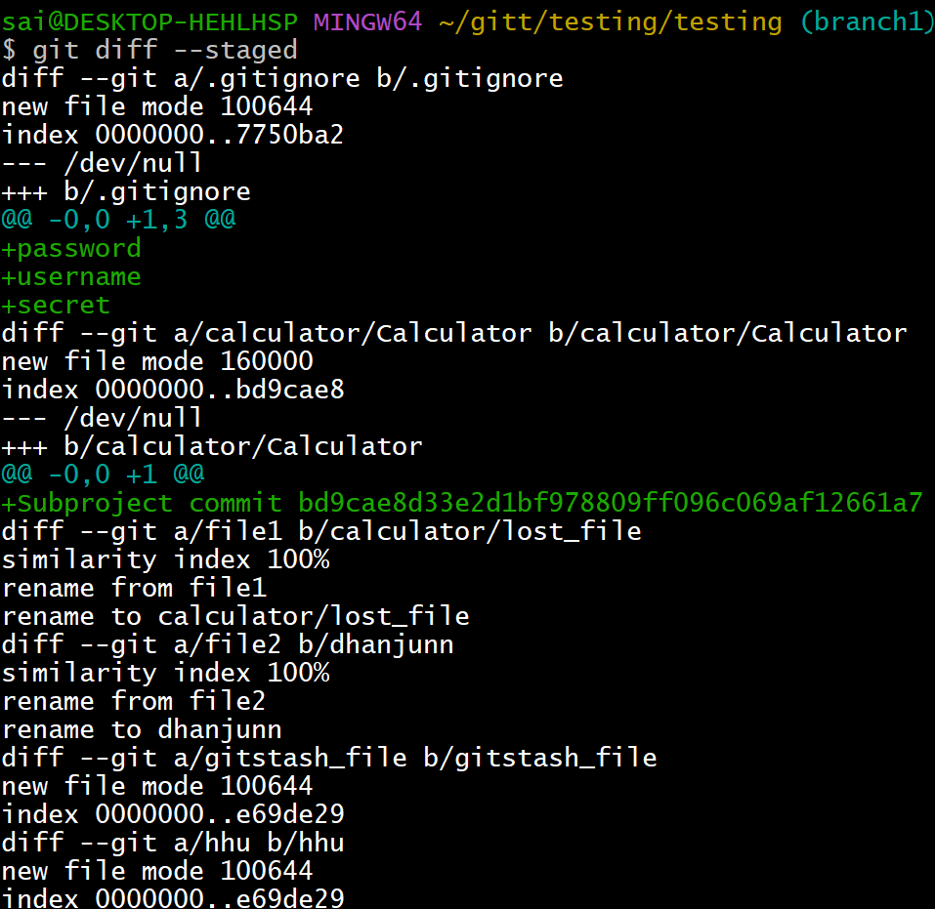

- git diff : Shows the differences between your working directory and a specific commit.
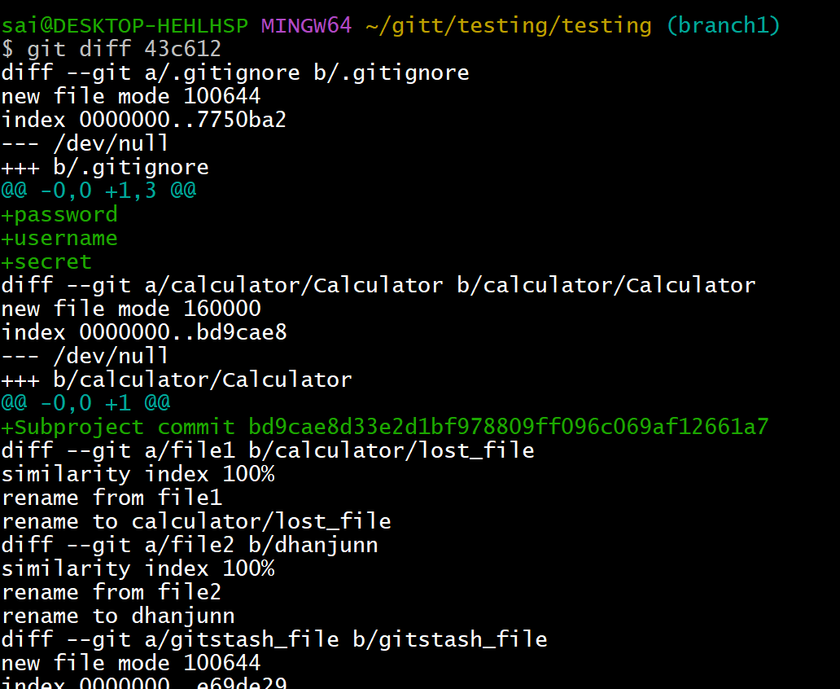

- git log: Displays the commit history
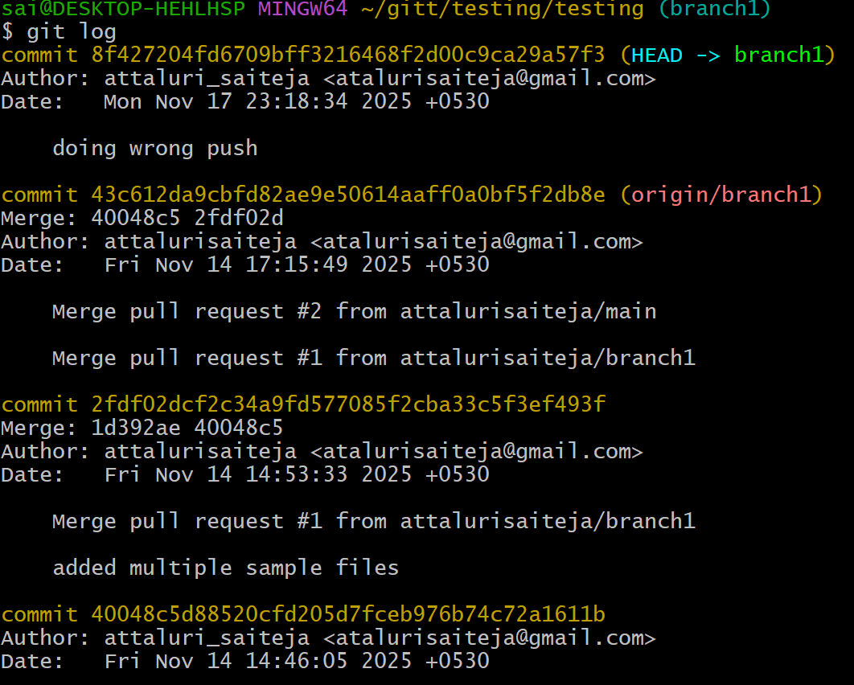
- git log --oneline: Displays the commit history in a simplified one-line format.
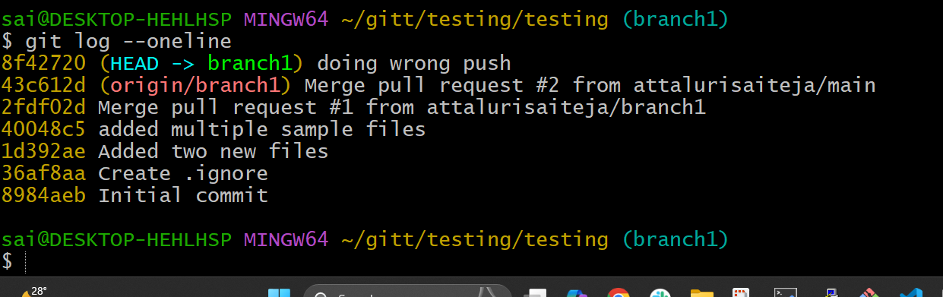
- git log --graph: Displays the commit history as a graph.
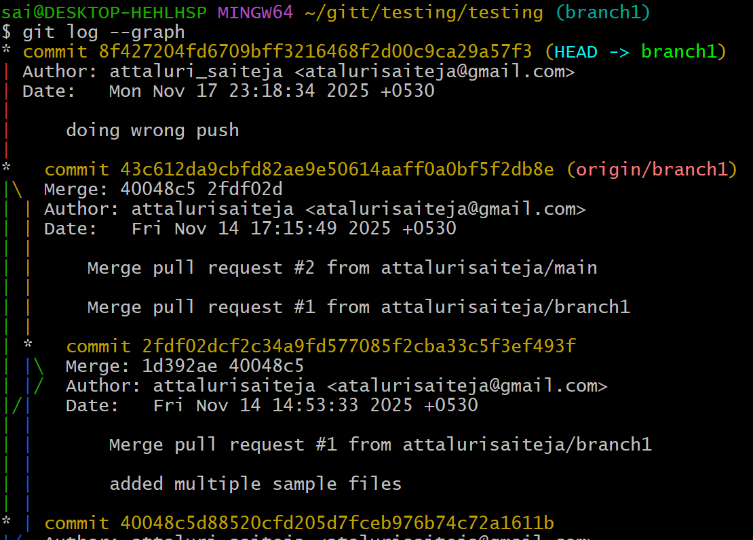

- git log --author="name": Filters commits by a specific author.
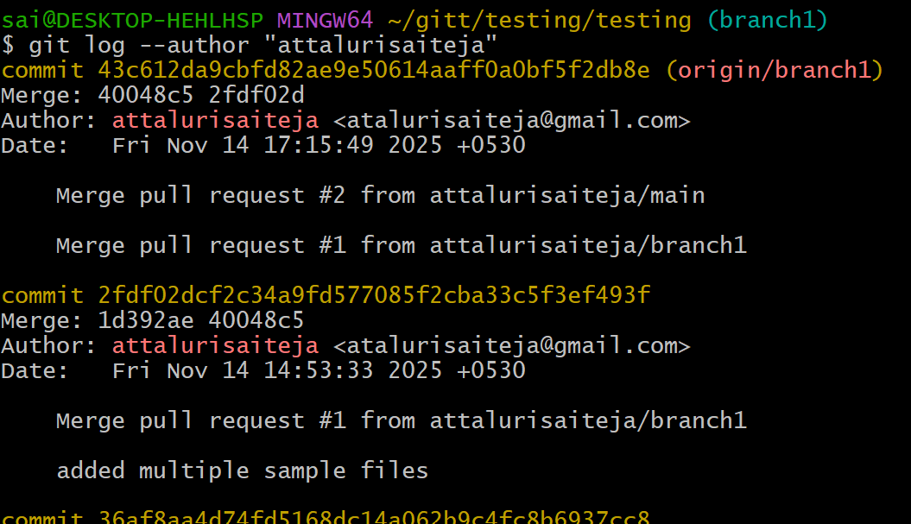
- git log --since="2 weeks ago": Filters commits made after a specific date.
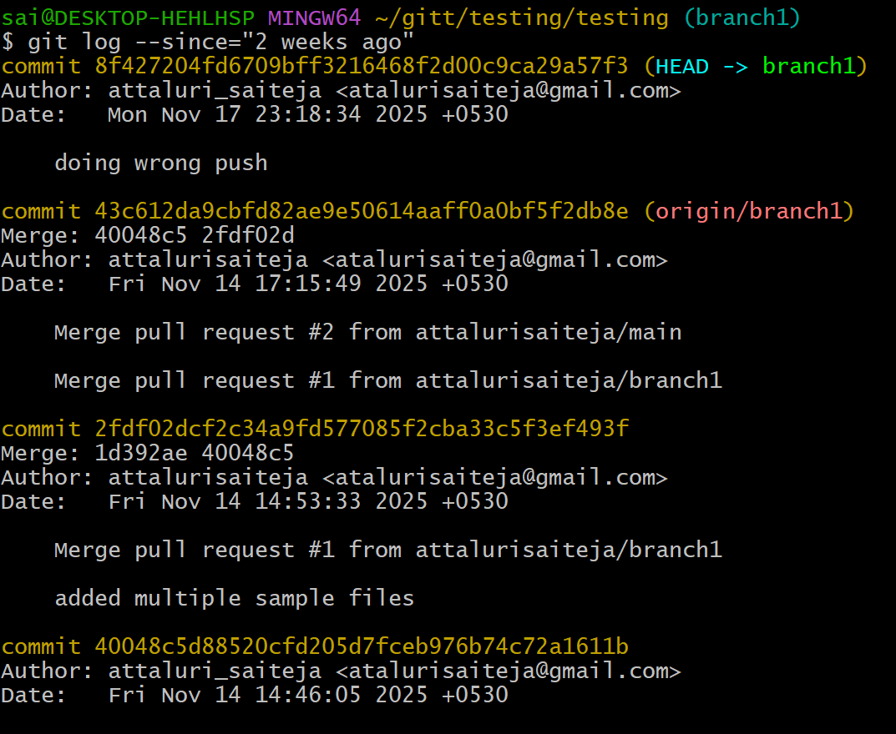
- git blame : Shows line-by-line annotations for a file, telling who last modified each line.
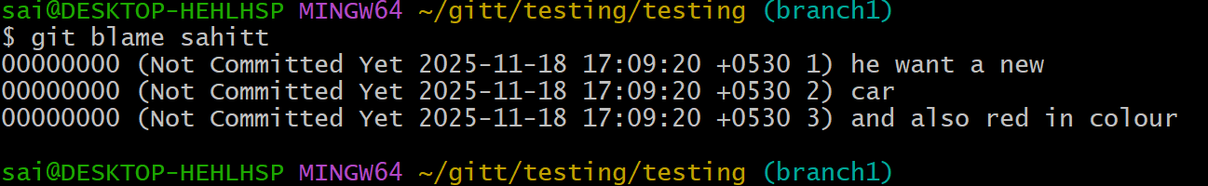
- git show : Shows details of a specific commit (including diff and metadata).
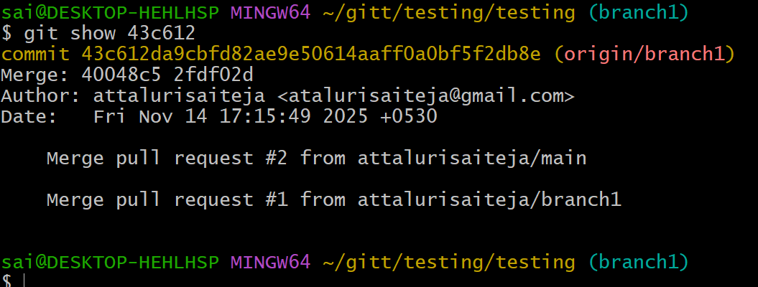

- git show :: Shows a specific file at a particular commit.
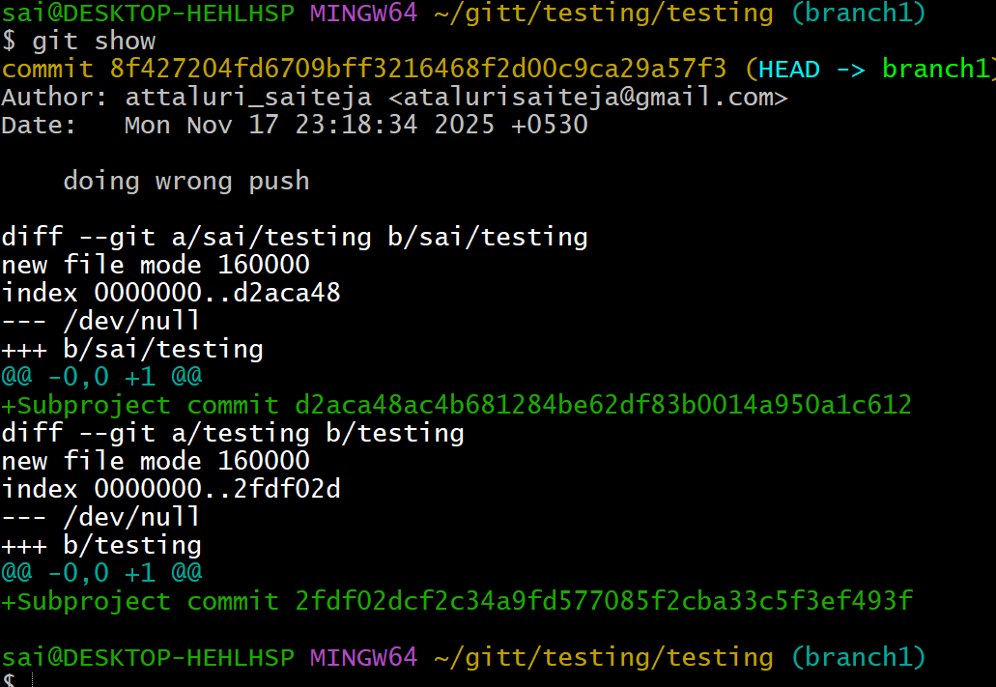
6. Reverting and Resetting (Undoing changes)
git reset : Moves HEAD to a specific commit, leaving your working directory intact (can be used with --soft, - mixed, or --hard).
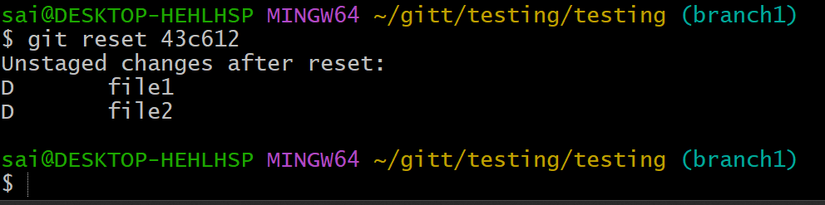
git reset --hard : Resets your working directory, index, and HEAD to a specific commit (all changes will be lost).
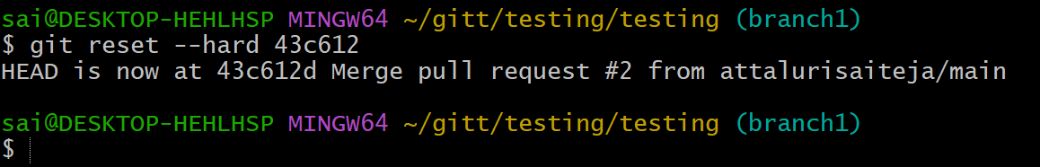
git reset --soft : Resets only the HEAD to a specific commit, leaving staged changes.
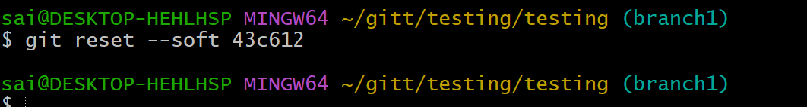
git reset --mixed : Resets the HEAD and index to a specific commit but keeps the working directory unchanged.
“Move the branch pointer to <commit-id> and unstage everything,
but KEEP all file changes in the working directory.”
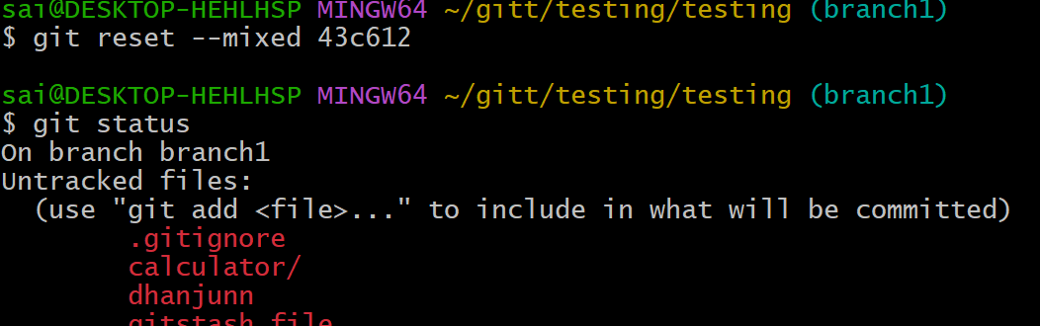
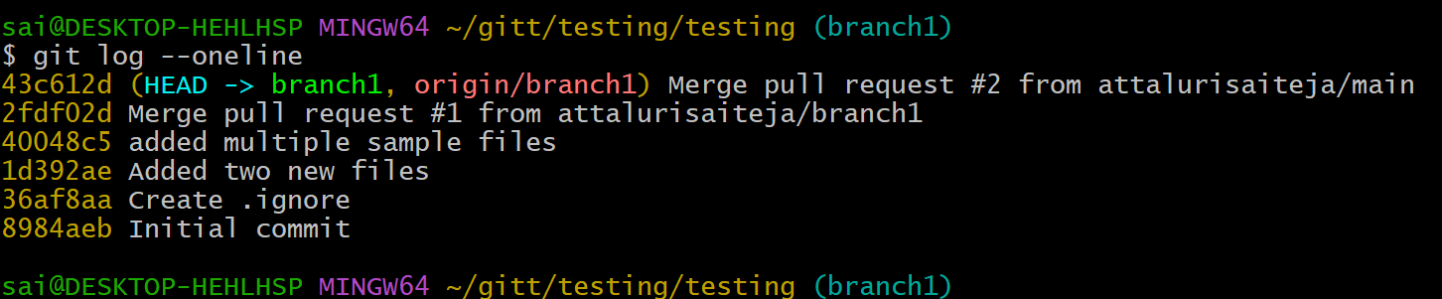
git revert : Creates a new commit that undoes the changes of the specified commit
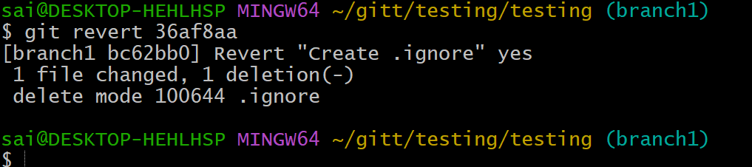

git restore : Restores the file(s) in the working directory from the index or a commit.
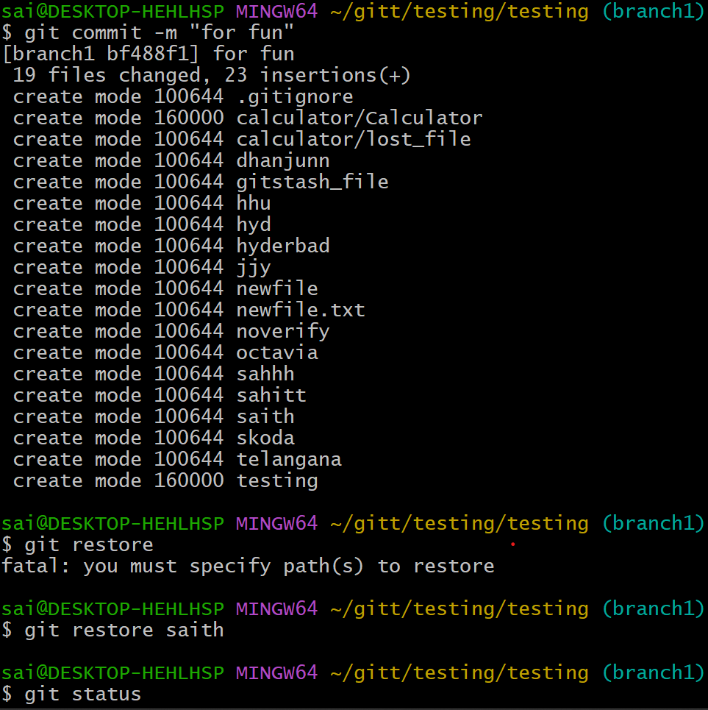
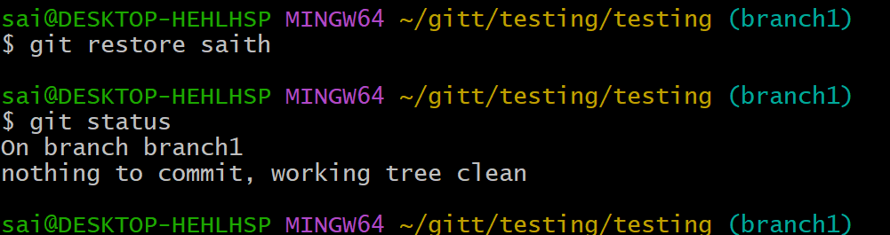
- git restore --staged : Removes a file from the staging area.
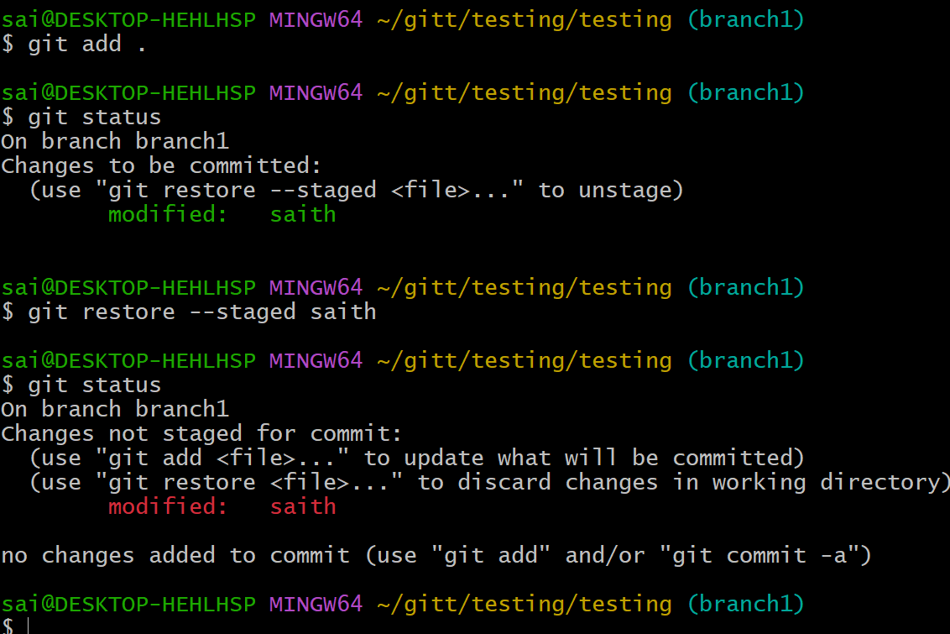
git clean -f: Removes untracked files in the working directory.
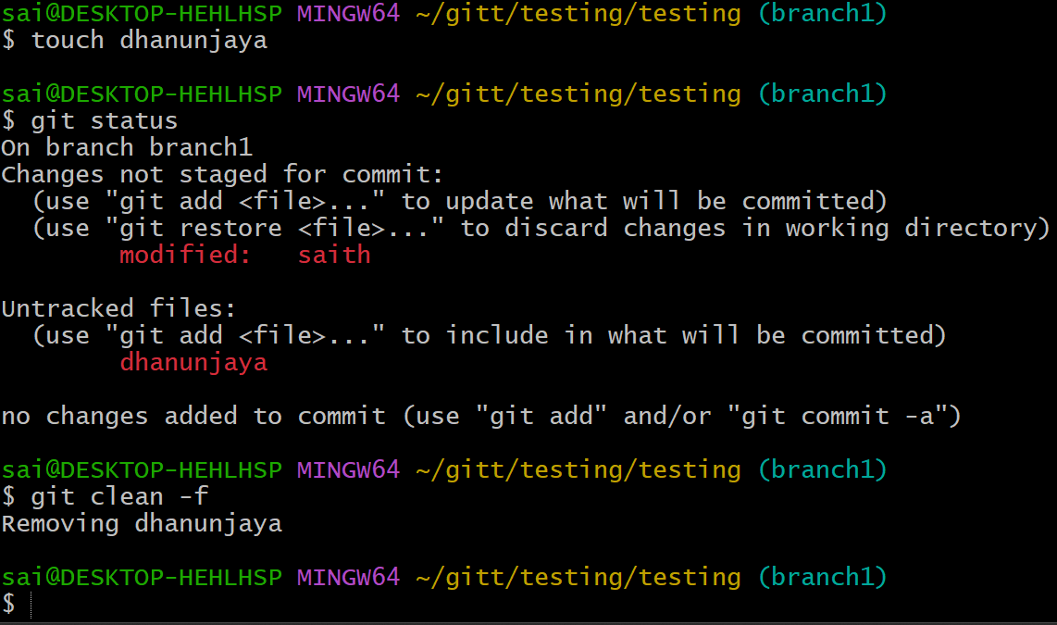
git clean -fd: Removes untracked files and directories.
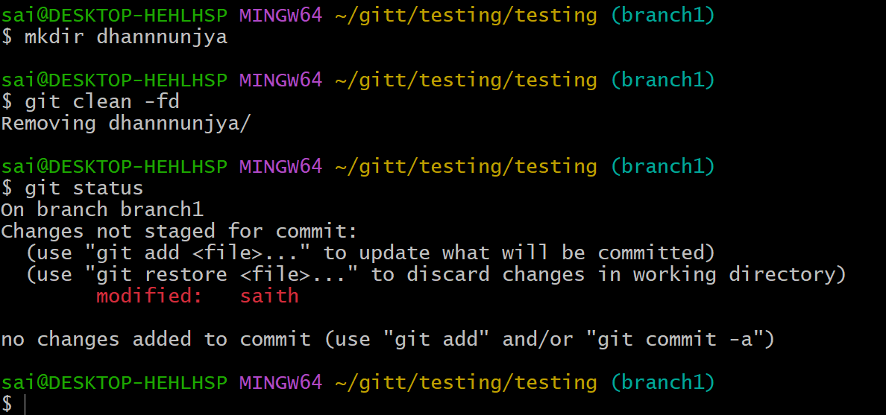
7. Stashing (Temporarily saving changes)
• git stash: Stashes the changes in your working directory (both staged and unstaged).
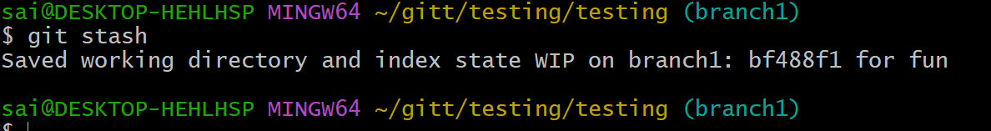
git stash list: Lists all the stashes.
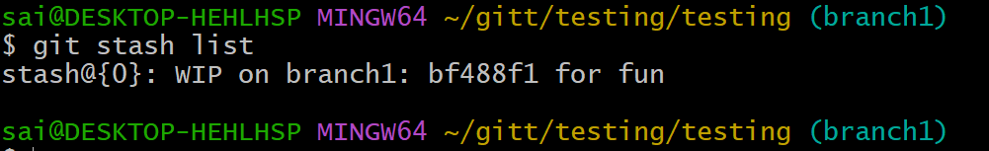
git stash pop: Applies the latest stash and removes it from the stash list.
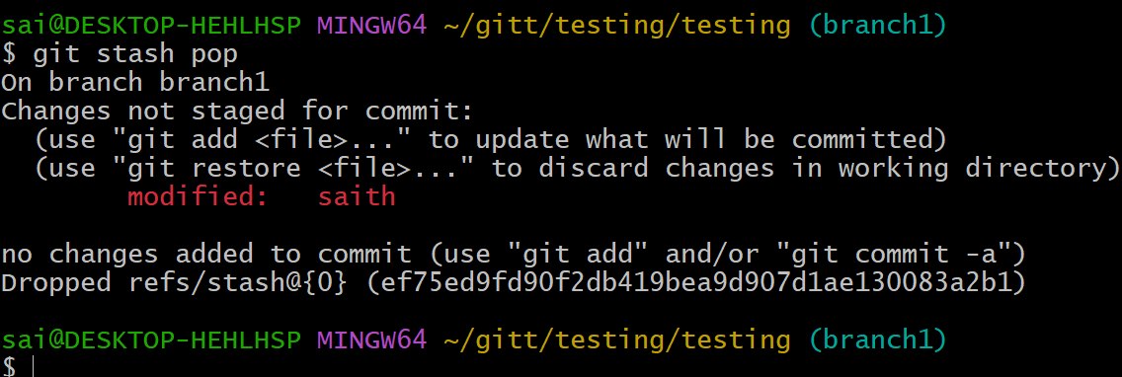
git stash apply: Applies a stash without removing it from the list.
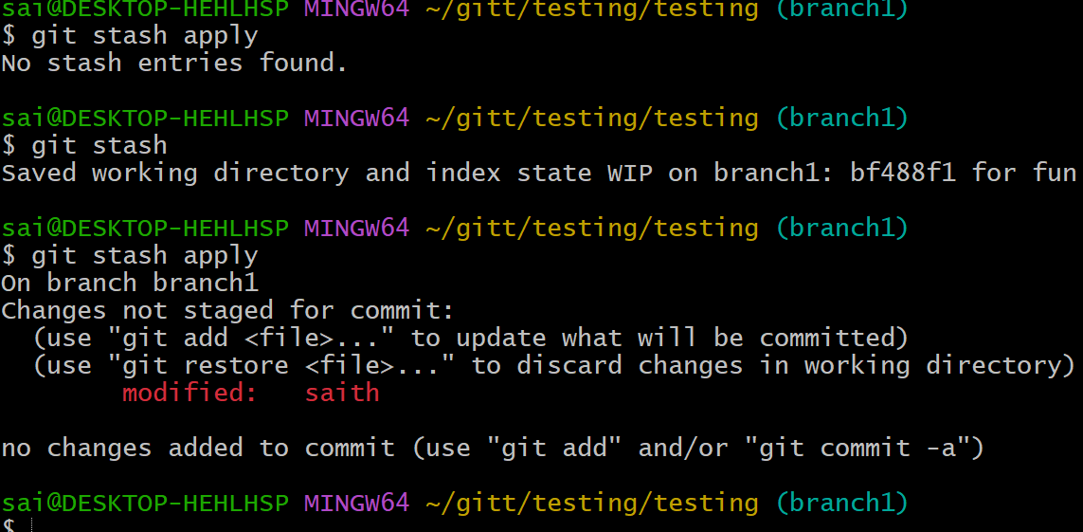
git stash drop: Removes a specific stash from the stash list.
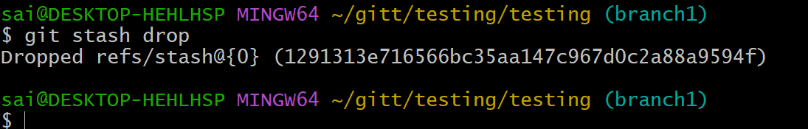
git stash clear: Clears all stashes.
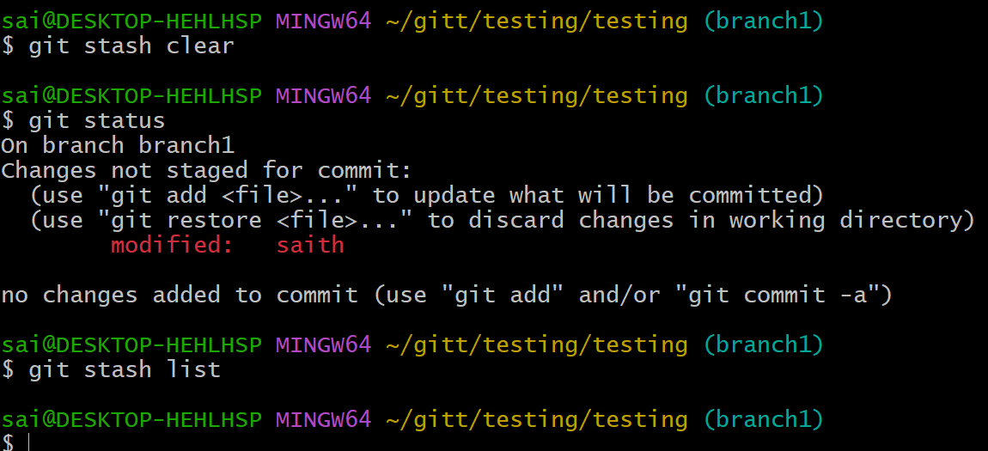

git stash save "message": Stashes changes with an optional message for identification.
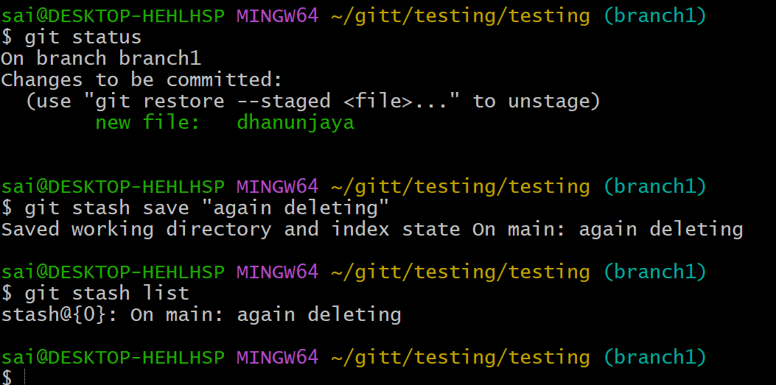
git stash branch : Creates a new branch from the stash and applies it.
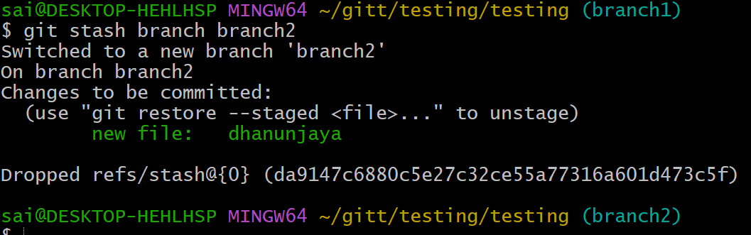

8. Tags (Managing versions)
git tag: Lists all tags in the repository.
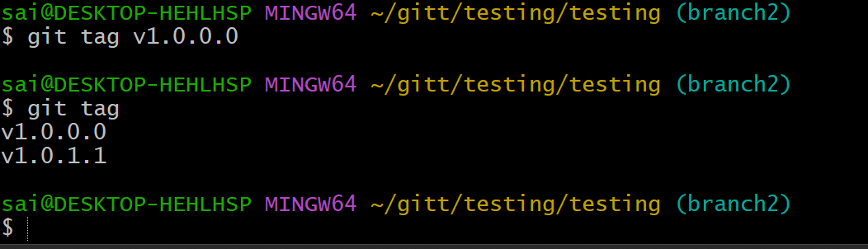
git tag : Creates a new tag at the current commit.
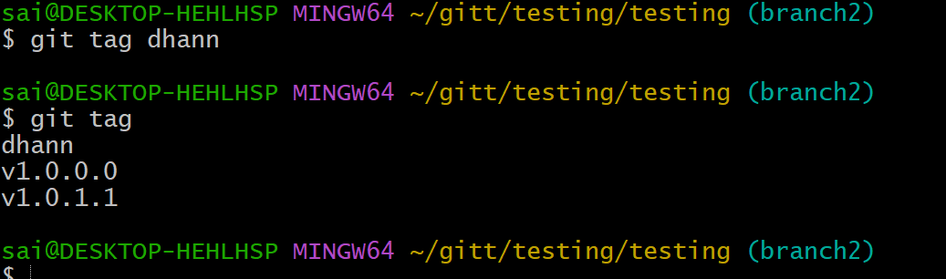
git tag -a -m "message": Creates an annotated tag with a message
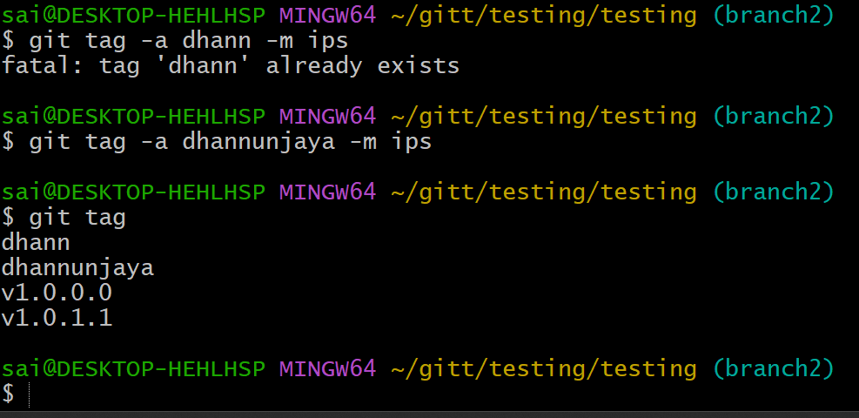
git tag -d : Deletes a tag locally.
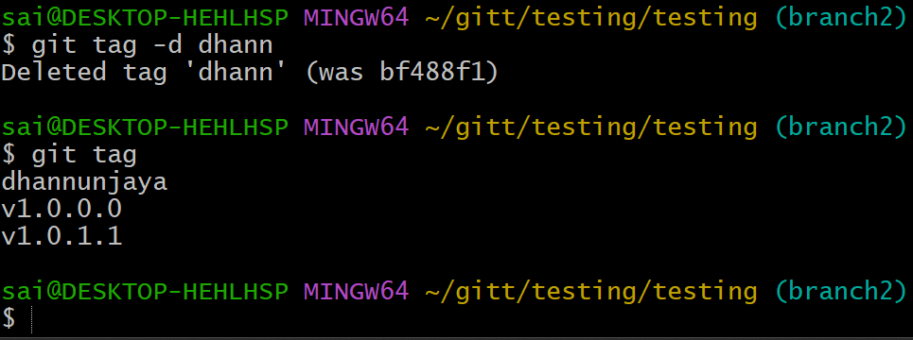

git push origin : Pushes a specific tag to the remote repository.
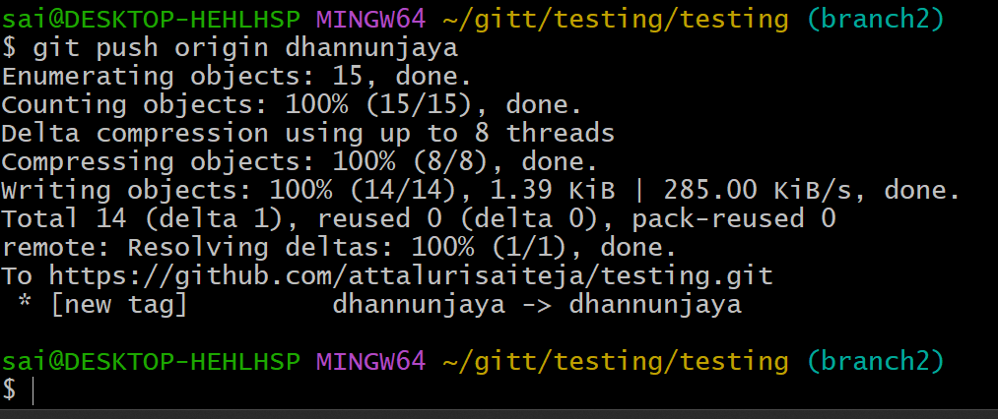
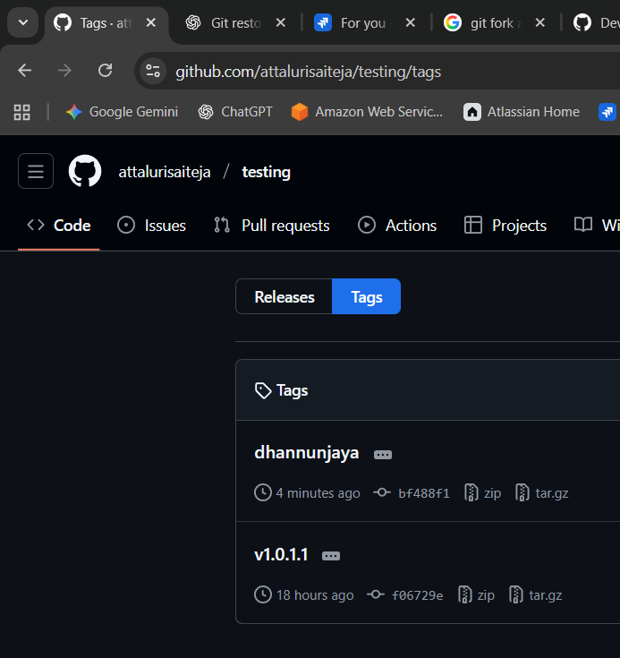
git push origin --tags: Pushes all tags to the remote repository.
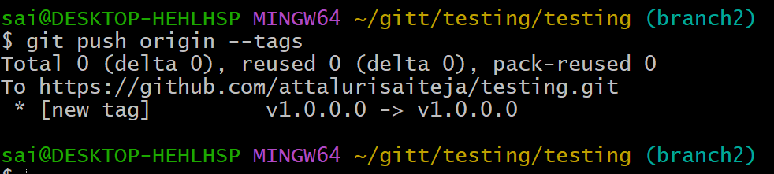
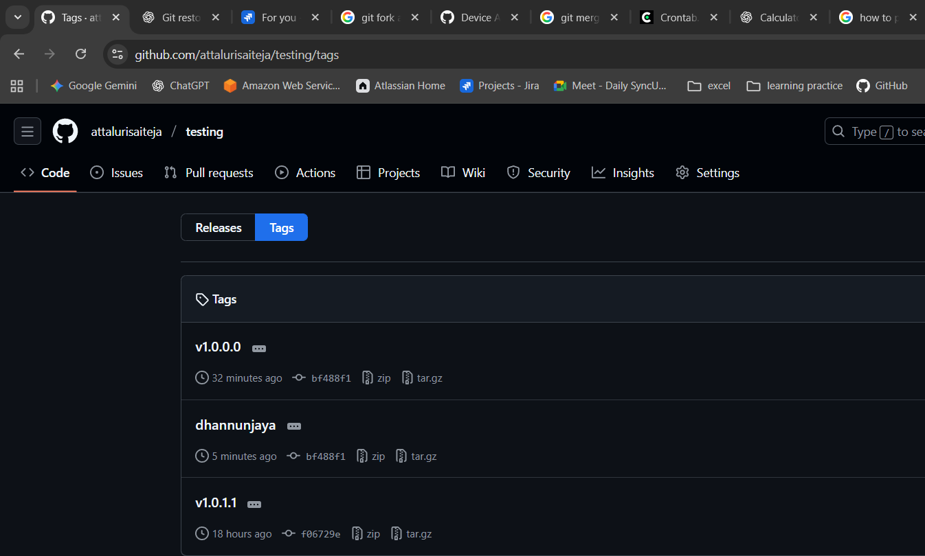
git fetch --tags: Fetches all tags from the remote repository.
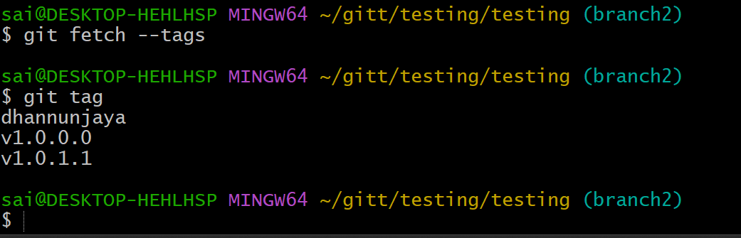

9. Git Config and Info (Configuration and repository information)
• git config --global user.name "Your Name": Sets your global username for commits.
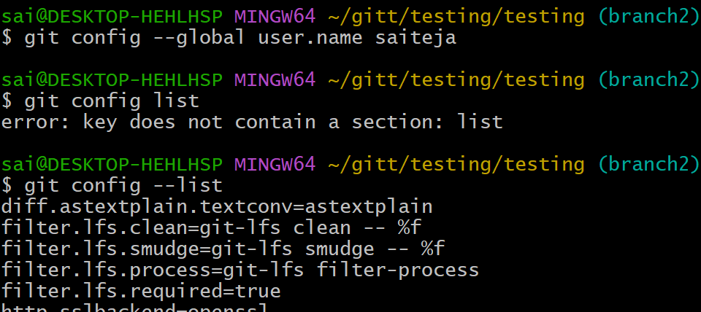
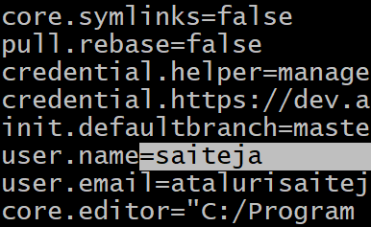
git config --global user.email "youremail@example.com": Sets your global email for commits.
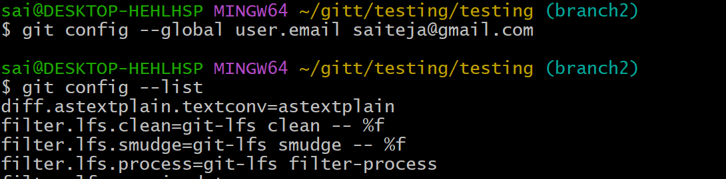
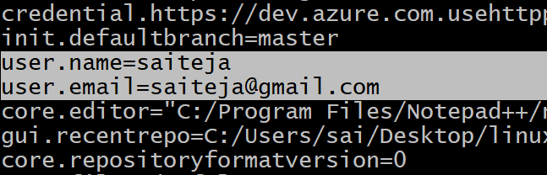
git config --list: Lists all configuration settings.
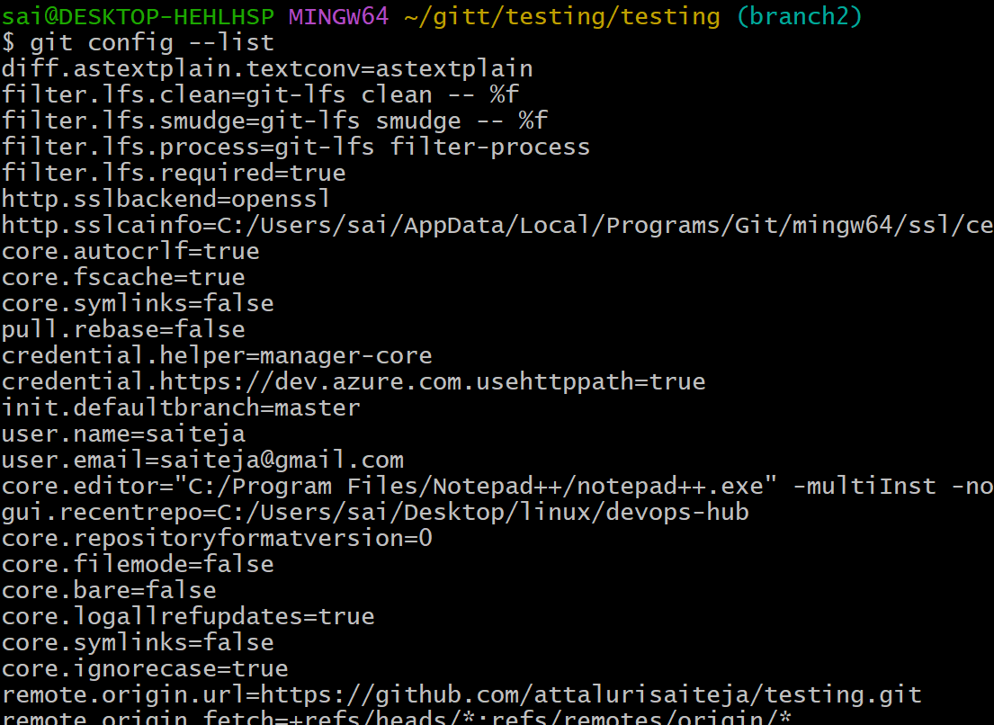

git config : Sets a specific configuration option.
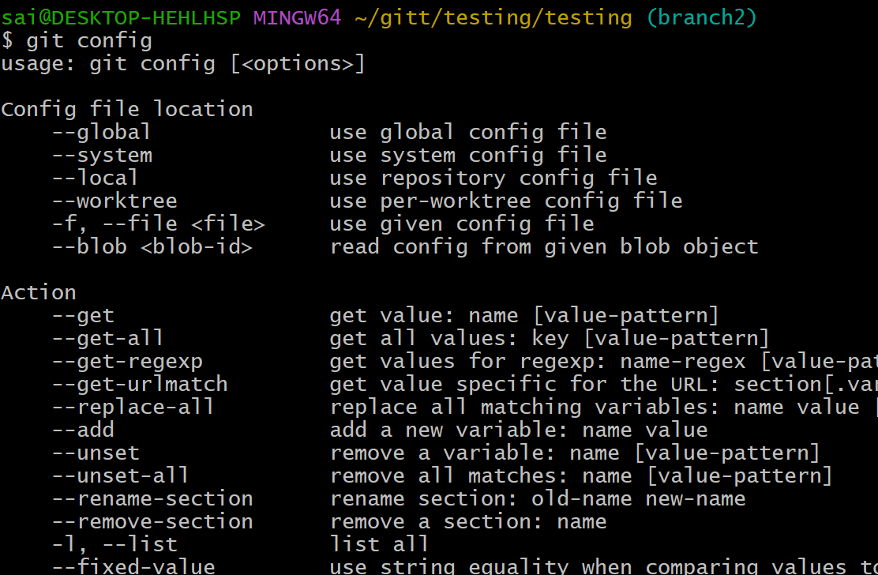
git config --global core.editor : Sets the default text editor for Git.
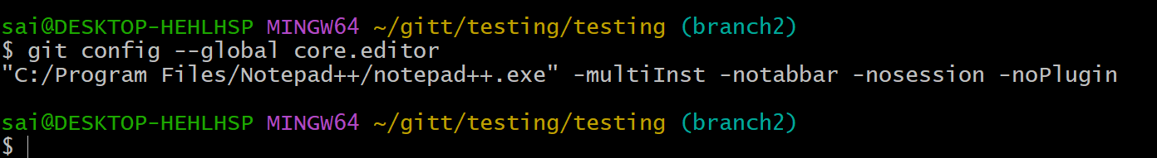
git config --global color.ui true: Enables colored output in Git.
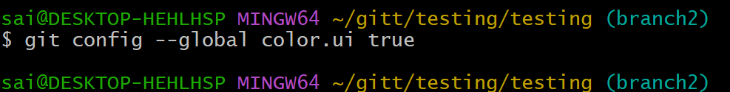

git config --global alias.st status: Creates a custom Git alias (e.g., git st for git status).
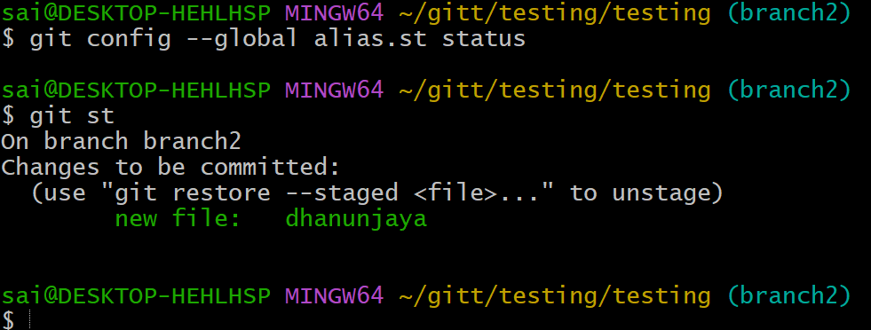

10. Git Aliases (Custom commands)
git config --global alias. : Creates a new Git alias for an existing command. Example: git config --global alias.co checkout
